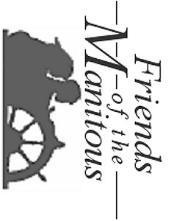
William J Strating – Secretary
Friends of the Manitous
PO Box 987
Empire MI 49630-0987
JEFFERY THOMAS
PAPPLE-PITTERSON PRINTING INC
PO BOX 123
FREELAND MI 48623-0123

