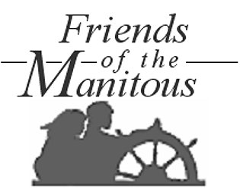
Join & Support the Friends ...
... and help us preserve and interpret the history and cultural traditions of the Manitou Islands.
Receive a formal membership certificate, all issues of the Friends Newsletter, access to www.friendsofthemanitous.org, invitations to all meetings, outings, work projects and other events, and you’ll share all other rights and benefits of membership in the Society.
New members, secure your lifetime personal or family membership by returning this envelope along with a one-time membership contribution of as little as $10.00! Old friends, use this envelope for comments, contributions, orders and signups.

