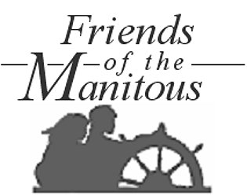
We help preserve the history and cultural traditions of Michigan’s Manitou Islands.

