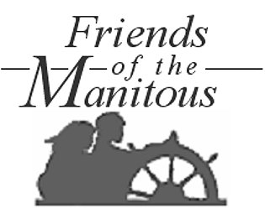
Primary Member _________________________________________________________________

Address _______________________________________________________________________
City _______________________________________ State _____ ZIP ______________________
Phone __________________________ email _________________________________________
Associate Member (Spouse, etc.) ___________________________________________________
Children (at home) _______________________________________________________________
Contributions: □ $10 □ $20 □ $50 □ $100 □ $250 □ $500 □ Other $ __________
The Friends of the Manitous is a 501(c)(3) publicly supported charitable organization. Your remittance is therefore deductible as a charitable contribution. Save postage – join/contribute online at http://www.friendsofthemanitous.org/.
Join & Support the Friends ...
... and help us preserve and interpret the history and cultural traditions of the Manitou Islands.
Receive a formal membership certificate, all issues of the Friends Newsletter, access to www.friendsofthemanitous.org, invitations to all meetings, outings, work projects and other events, and you’ll share all other rights and benefits of membership in the Society.
New members, secure your lifetime personal or family membership by returning this envelope along with a one-time membership contribution of as little as $10.00! Old friends, use this envelope for comments, contributions, orders and signups.

