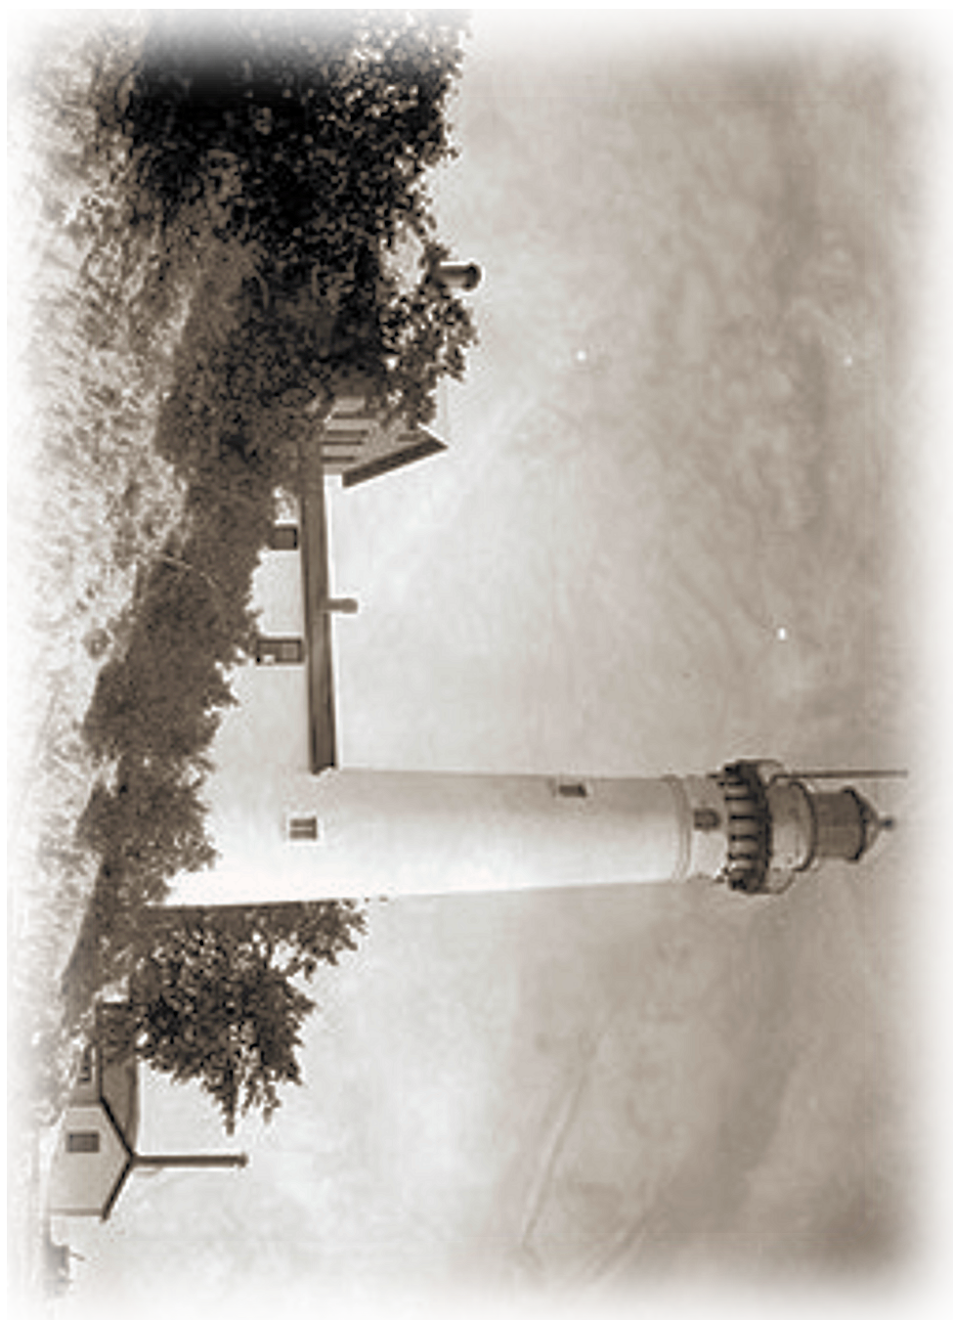

Commissioned in 1872, this third and final lighthouse served on South Manitou Island for over 100-years. Towers in this class, designed by Army-trained engineer Orlando Poe, are considered among the most graceful and beautiful ever built. A familiar landmark for sailors navigating the Manitou Passage, this gleaming white structure is also clearly visible from the mainland, and now stands as a symbol of the Island's rich history and romantic cultural traditions. (Photograph from U.S.Coast Guard archives - date uncertain.)
Original design created for the
Friends of the Manitous
Empire, Michigan 49630-0987 USA
www.friendsofthmanitous.org

©2007 FotM

John & Jane Doe, 800 Warren Woods Rd, Twin Oaks, MI 49128-8925 616-555-1212

