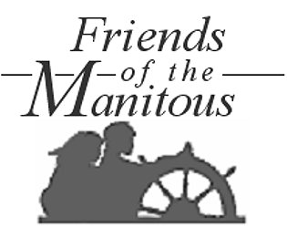

This personalized note stationery is provided with compliments of the Friends of the Manitous. Thank you for your continuing interest and support!

