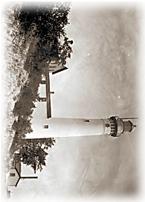

John & Jane Doe
800 Warren Woods Rd
Twin Oaks, MI 49128-8925

