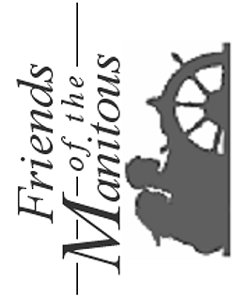
Friends of the Manitous
PO Box 987
Empire MI 49630-0987

