
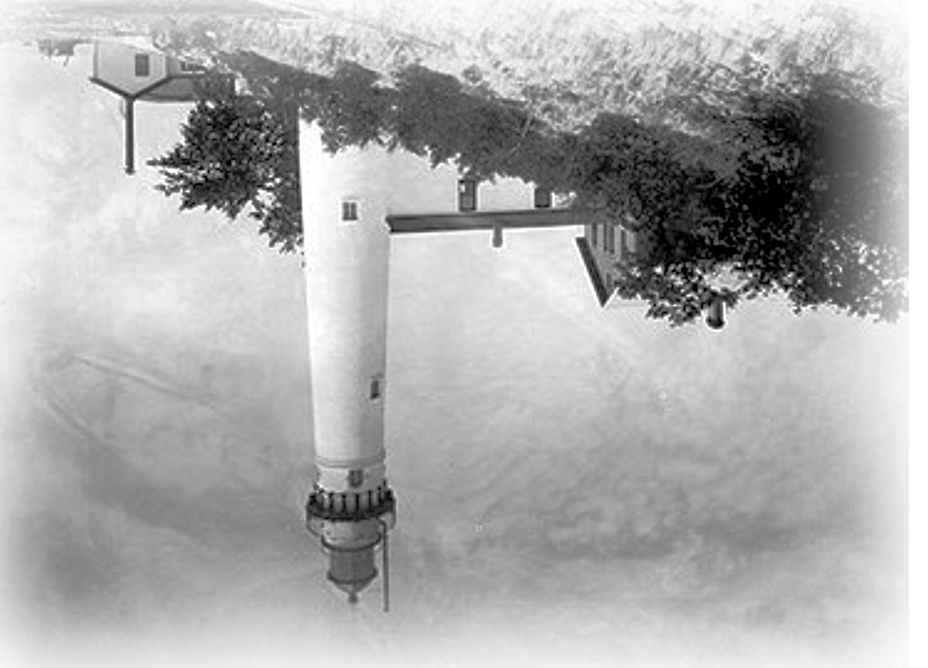
"No man is an island, entire of itself; every man is a piece of the continent, a part of the main. If a clod be washed away by the sea, the land is the less, as well as if a promontory were ... Any man's death diminishes me, because I am involved in mankind; and therefore never send to know for whom the bell tolls; it tolls for thee."

John Donne (1573-1631)
"No man is an island, entire of itself; every man is a piece of the continent, a part of the main. If a clod be washed away by the sea, the land is the less, as well as if a promontory were ... Any man's death diminishes me, because I am involved in mankind; and therefore never send to know for whom the bell tolls; it tolls for thee."

John Donne (1573-1631)
Original design created by
Friends of the Manitous
Empire, Michigan 49630-0987 USA
www.friendsofthemanitous.org
© 2007 FotM
Original design created by
Friends of the Manitous
Empire, Michigan 49630-0987 USA
www.friendsofthemanitous.org
© 2007 FotM

