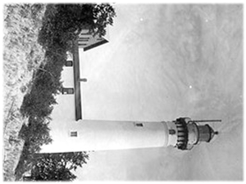
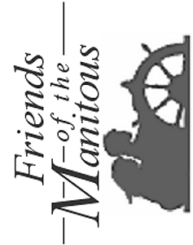
Friends of the Manitous
PO Box 987
Empire MI 49630-0987
John Doe
8859 Ferry St
Montague MI 49437-1222

