Volunteer Achievement Award

John Doe

This certifies that

July 29, 2007
The Friends of the Manitous is a Michigan Nonprofit Corporation operating as a Charitable Organization ~ www.friendsofthemanitous.org.
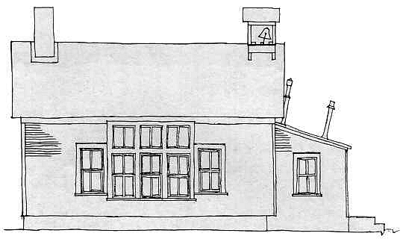
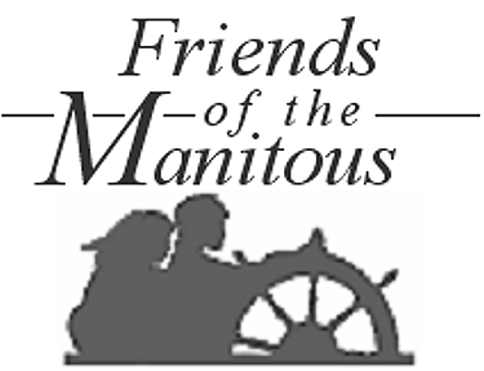
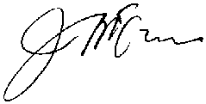
South Manitou Island Workshop
Served with distinction as a member of the Friends of the Manitous and Volunteer on South Manitou Island, a unit of the Sleeping Bear Dunes National Lakeshore, Leelanau County, Michigan. Accomplishments of the crew included the preservation of the Island’s historic one-room schoolhouse, stabilization of the Harrison Haas fish shanty, stabilization of outbuildings on the George Conrad Hutzler farmstead, Recovery of island agricultural landscapes, and other initiatives. These contributions of personal skills, labor and time will assure rich experiences for Island visitors for many years to come, and are therefore highly valued and sincerely appreciated.
Awarded by the Friends of the Manitous at the Annual Meeting in the Sleeping Bear Dunes National Lakeshore at Empire, Michigan on
John C McCann
President

Date

