Friends of the Manitous

Manitou Island Transit

This Certificate is Awarded to

July 29, 2007
John C McCann
President

William J Strating
Secretary

The Friends of the Manitous is a Michigan Nonprofit Corporation operating as a Charitable Organization ~ www.friendsofthemanitous.org.
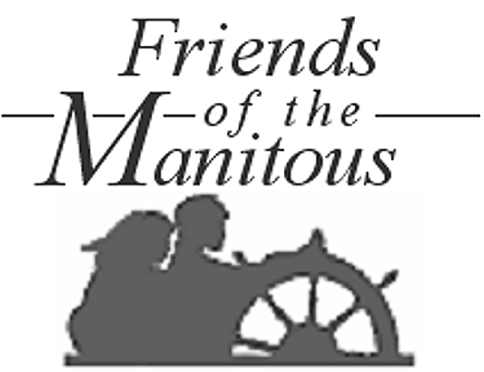
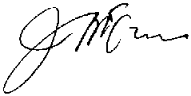
Certificate of Appreciation
In recognition of services and special considerations generously rendered to the Memorial Society and its Volunteers on South Manitou Island, enabling the successful accomplishment of projects including the preservation of the Island’s historic one-room schoolhouse, stabilization of the Harrison Haas fish shanty, stabilization of outbuildings on the George Conrad Hutzler and Theodore Beck farmsteads, Recovery of island agricultural landscapes, and other initiatives. These contributions, above and beyond what might reasonable have been expected, will assure rich experiences for Island visitors over many years to come, and are therefore highly valued and sincerely appreciated.

Awarded at the Annual Meeting in Empire, Michigan on

