Friends of the Manitous

John & Mary Doe

This is to certify that
This certificate issued on

June 30, 2007
John C McCann
President

William J Strating
Secretary

This certificate is valid for one year from date of issue, and is renewable upon application in person, in writing or electronically at www.friendsofthemanitous.org.
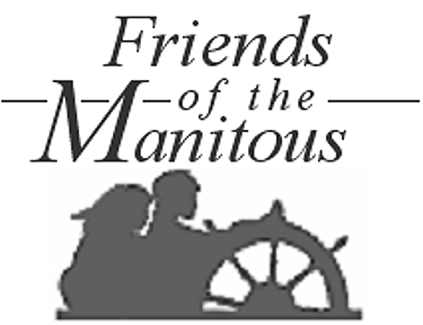
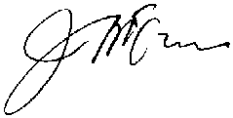
MEMBER
Are members in good standing of the Friends of the Manitous of Empire, Michigan, U.S.A. The Friends of the Manitous is a nonprofit cheritable organization charted by the State of Michigan to preserve the history and cultural traditions of Michigan’s Manitou Islands, to distribute educational and interpretive materials and programs, to keep records of burials and gravesites of original settlers and others interred on the Islands, to promote the proper care and maintenance of the Islands’ historic and cultural assets, and to support the Sleeping Bear Dunes National Lakeshore as volunteers on the Islands.

