Friends of the Lakeshore

Jane (Doe) Jones

This Certificate is Awarded to
John C McCann
President

William J Strating
Secretary

The Friends of the Lakeshore is a Michigan Nonprofit Corporation operating as a Charitable Organization ~ www.friendsofthelakeshore.org.
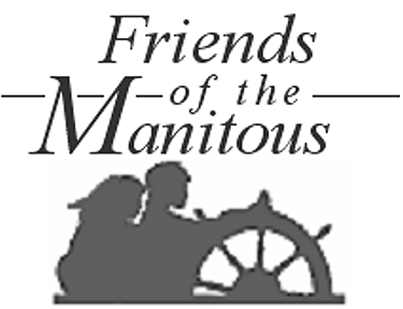
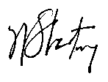
Charter Member - Centenarian
In recognition of 100-years of unfailing affection for and devotion to North and South Manitou Islands, as evidenced by her continuing support of the Annual North and South Manitou Islands Reunion and the Friends of the Lakeshore. Special recognition certificates are presented exclusively to members who make a significant contribution to the society’s mission of preserving and disseminating knowledge of the history and culture of Michigan’s North and South Manitou Islands.
Awarded at the Annual Meeting in Empire, Michigan on

July 29, 2007

