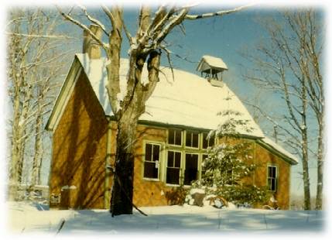
South Manitou Island Schoolhouse  The one-room South Manitou Island School, built in 1899, served island kids of all ages, from the first through the eighth grade. Its most famous alumnus was Willard Smith, who grew to be become Commandant of the U.S. Coast Guard. Teachers were usually young, often on their first job. The little schoolhouse also served as a place for meetings and social activities. After sitting idle for over sixty years, a small but dedicated corps of volunteers, working under the direction of NPS historians and interpreters, have restored the building, making this nostalgic and historic place a highlight of island visits. | South Manitou Island Schoolhouse  The one-room South Manitou Island School, built in 1899, served island kids of all ages, from the first through the eighth grade. Its most famous alumnus was Willard Smith, who grew to be become Commandant of the U.S. Coast Guard. Teachers were usually young, often on their first job. The little schoolhouse also served as a place for meetings and social activities. After sitting idle for over sixty years, a small but dedicated corps of volunteers, working under the direction of NPS historians and interpreters, have restored the building, making this nostalgic and historic place a highlight of island visits. | South Manitou Island Schoolhouse  The one-room South Manitou Island School, built in 1899, served island kids of all ages, from the first through the eighth grade. Its most famous alumnus was Willard Smith, who grew to be become Commandant of the U.S. Coast Guard. Teachers were usually young, often on their first job. The little schoolhouse also served as a place for meetings and social activities. After sitting idle for over sixty years, a small but dedicated corps of volunteers, working under the direction of NPS historians and interpreters, have restored the building, making this nostalgic and historic place a highlight of island visits. | South Manitou Island Schoolhouse  The one-room South Manitou Island School, built in 1899, served island kids of all ages, from the first through the eighth grade. Its most famous alumnus was Willard Smith, who grew to be become Commandant of the U.S. Coast Guard. Teachers were usually young, often on their first job. The little schoolhouse also served as a place for meetings and social activities. After sitting idle for over sixty years, a small but dedicated corps of volunteers, working under the direction of NPS historians and interpreters, have restored the building, making this nostalgic and historic place a highlight of island visits. | South Manitou Island Schoolhouse  The one-room South Manitou Island School, built in 1899, served island kids of all ages, from the first through the eighth grade. Its most famous alumnus was Willard Smith, who grew to be become Commandant of the U.S. Coast Guard. Teachers were usually young, often on their first job. The little schoolhouse also served as a place for meetings and social activities. After sitting idle for over sixty years, a small but dedicated corps of volunteers, working under the direction of NPS historians and interpreters, have restored the building, making this nostalgic and historic place a highlight of island visits. | South Manitou Island Schoolhouse  The one-room South Manitou Island School, built in 1899, served island kids of all ages, from the first through the eighth grade. Its most famous alumnus was Willard Smith, who grew to be become Commandant of the U.S. Coast Guard. Teachers were usually young, often on their first job. The little schoolhouse also served as a place for meetings and social activities. After sitting idle for over sixty years, a small but dedicated corps of volunteers, working under the direction of NPS historians and interpreters, have restored the building, making this nostalgic and historic place a highlight of island visits.
Original design created for  Friends of the Manitous  Empire, Michigan  49630-0987 USA  www.friendsofthemanitous.org  © 2007 FotM | Original design created for  Friends of the Manitous  Empire, Michigan  49630-0987 USA  www.friendsofthemanitous.org  © 2007 FotM | Original design created for  Friends of the Manitous  Empire, Michigan  49630-0987 USA  www.friendsofthemanitous.org  © 2007 FotM | Original design created for  Friends of the Manitous  Empire, Michigan  49630-0987 USA  www.friendsofthemanitous.org  © 2007 FotM | Original design created for  Friends of the Manitous  Empire, Michigan  49630-0987 USA  www.friendsofthemanitous.org  © 2007 FotM | Original design created for  Friends of the Manitous  Empire, Michigan  49630-0987 USA  www.friendsofthemanitous.org  © 2007 FotM

