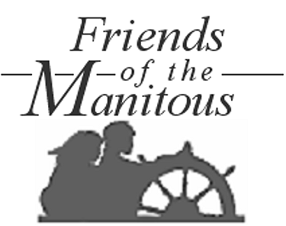
MINUTES
__________
Friends of the Manitous
3rd ANNUAL Meeting

EMPIRE TOWNSHIP HALL
Empire, MI
JULY 26, 2008 – 11:00 AM

- Call to Order – 11:04 AM
- Welcoming Comments – John McCann
- Approval of the Agenda – unanimous
- Approval of the Minutes – July 28, 2007 Regular Meeting
Note: The minutes were reviewed and approved by the Board [RONR(10th Ed.),p.457,L.20-32]. No additional corrections.
- Secretary’s Report
  - The mailing list now includes 276 members, 11 prospective members and 36 “interested third parties”.
  - Since this time last year, the Friends has gained 46 new members, who contributed a total of $2,875 with their membership applications.
  - Other contributors numbered 85, for a total of $6,891.
  - A letter of appreciation has been received from the Superintendent of Sleeping Bear Dunes National Lakeshore for support provided by the Friends during the 2007 visitor season. Copies of the letter may be found on the handout table.
- Treasurer’s Report
  - Copies of the annual financial reports for the fiscal year ended June 30, 2008, as given in the Annual Report are attached.
- Nominating Committee Report
  - The elected positions of President and Secretary are open for election at this meeting. The nominees are:
    - President: Jane C Smith
    - Secretary: Walter K Madden
- Special Orders
  - Election of Officers – Smith and Madden unanimously elected
  - Election of the Nominating Committee – Thomas TenBrink, Theo Walters and Janet Edmundson were elected by general consent
  - Selection of Appointees – there were no volunteers for appointed board positions.
- New Business
  - Recognition of Special Achievements
    - Walter J Elwell – 25 years as volunteer North Manitou Island historian and preservationist; Honorary Lifetime Membership.
    - Billy Williams Jr – 2007 volunteer youth interpreter on South Manitou Island; Special Achievement Award
    - Merriam L Kitchen – Centenarian; oldest surviving descendant of island settlers, original Friends advisor and oldest Charter Member; Certificate of Appreciation
    - Manitou Island Transit – for volunteering and assisting with the transportation of personnel, equipment and supplies for projects on North and South Manitou Islands; Certificate of Appreciation.
  - Introduction of modeler Edward Howard and his proposal to create topographic models (relief map models) of North and South Manitou Islands.
  - Presentation of the Lakeshore’s “wish list” – consideration of opportunities for supporting the Lakeshore financially and with volunteer projects during the 2009 visitor season.
- Adjournment – 11:47 AM

- Open Discussion
- Announcements.
- Luncheon and Program

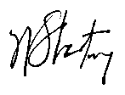

Adopted by the Board in the meeting

of _________________________,
(Date of Meeting)

____________________________
(Signature of Presiding Officer)

Respectfully submitted by,

William J Strating
Secretary

