
Notice of Meeting
3rd Quarter Board Of Directors Meeting
Date of Notice: July 28, 2005

A meeting of the Board of Directors of the Friends of the Manitous, Inc has been called by President Wilbur Farnsworth for ...
Saturday, August 27, 2005 ~ 10:00 AM
Kalamazoo Valley Community College
Michigan Technical Training Center – Room A1030
7107 Elm Valley Drive
Kalamazoo, MI 49003-4070
The general purpose of the meeting is to discuss fund management, project planning, budgeting and accounting practices. The discussion of other matters will also be in order. The draft agenda for this meeting is included in this packet, along with the various captioned references.
A complete catered picnic lunch will be provided on the beautiful grounds of the MTEC campus. Family members are welcome. (Public on-campus recreation facilities are suitable for all ages.)
Directions to the meeting are provided on the following page. If you need any further information, please feel free to email wilma_voss@friendsofthemanitous.org, or call me at 616-555-1212.
Wilma Voss – Secretary

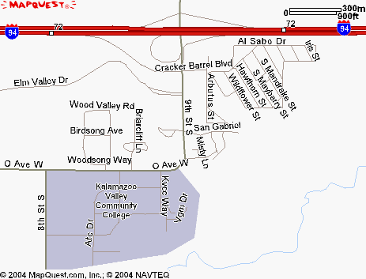
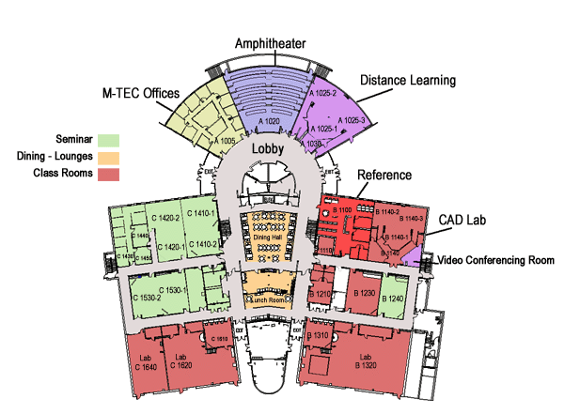


GETTING THERE
Michigan Technical Education Center (MTEC)
Take I-94 to Exit 72, Take 9th St. South, and travel about a quarter mile. You will see the entrance to The Groves, a business park, on the right. Turn into the Groves, continue to end to MTEC, approximately one mile down Elm Valley Drive, on the left (south) hand side of the road. Parking is available on either side of the facility. Enter the lobby at the front door and look for the sign directing you to Room A1030 (purple area), or ask “Charles”, the custodian for directions.

