
Official
Newsletter

V4 No 2 Summer 2005

3nd Annual Meeting

Friends of the Manitous
Saturday, July 26, 2008
10:00 AM
Empire Township Hall
Empire, MI 49630

2nd Annual
Manitou Island Excursion
Sunday, July 27, 2008
9:00 AM ~ 6:00 PM
Fishtown Dock
Leland, MI 49632

Please see page 7 for more information about these events.

Mishe-Mokwa Reservations

Space is Limited ~ Buy Your Tickets Today!
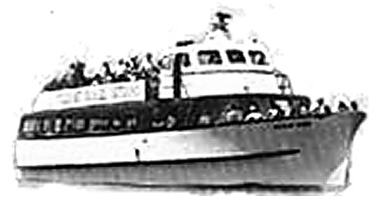
Transportation for the Island Excursion is provided by Manitou Island Transit. The voyage takes 90-minutes, departing Leland at 10:00 AM and leaving the Island in the afternoon at 4:30 PM.
The Mishe-Mokwa carries 133. At this writing, 46 seats have already been sold for Sunday, July 31. The July/August hump is right at the peak of the visitor season, so the boat is likely to be sold out on that day. If you plan to come along to the Island ... and we hope you will ... please consider making your reservations today. Tickets are $25 ($14 for kids 12 and under). You can reach Manitou Island Transit by calling 231-256-9061. They’re open daily, 8AM to 6PM. Credit cards are accepted over the telephone, or you may mail a check or money order to confirm your reservation.
Visit www.leelanau.com/manitou/ for more information.

Miracle Remedy for Sea Sickness!

Lorem ipsum dolor sit amet, consetetur sadipscing elitr, sed diam nonumy eirmod tempor invidunt ut labore et dolore magna aliquyam erat, sed diam voluptua. At vero eos et accusam et justo duo dolores et ea rebum. Stet clita kasd gubergren, no sea takimata sanctus est Lorem ipsum dolor sit amet. Lorem ipsum dolor sit amet, consetetur sadipscing elitr, sed diam nonumy eirmod tempor invidunt ut labore et dolore magna aliquyam erat, sed diam voluptua. At vero eos et accusam et justo duo dolores et ea rebum. Stet clita kasd gubergren, no sea takimata sanctus est Lorem ipsum dolor sit amet. Lorem ipsum dolor sit amet, consetetur sadipscing elitr, sed diam nonumy eirmod tempor invidunt ut labore et dolore magna aliquyam erat, sed diam voluptua. At vero eos et accusam et justo duo dolores et ea rebum. Stet clita kasd gubergren, no sea takimata sanctus est Lorem ipsum
Epsum factorial non deposit quid pro quo hic escorol. Olypian quarrels et gorilla congolium sic ad nauseum. Souvlaki ignitus carborundum e pluribus unum. Defacto lingo est igpay atinlay. Marquee selectus non provisio incongruous feline nolo contendre. Gratuitous octopus niacin, sodium gluti
Li Europan lingues
Li Europan lingues es membres del sam familie. Lor separat existentie es un myth. Por scientie, musica, sport etc., li tot Europa usa li sam vocabularium. Li lingues differe solmen in li grammatica, li pronunciation e li plu commun vocabules. Omnicos directe al desirabilit&aacute; de un nov lingua franca: on refusa continuar payar custosi traductores. It solmen va esser necessi far uniform.
Ma quande lingues coalesce, li grammatica del resultant lingue es plu simplic e regulari quam ti del coalescent lingues. Li nov lingua franca va esser plu simplic e regulari quam li existent Europan lingues. It va esser tam simplic quam Occidental: in fact, it va esser Occidental. A un Angleso it va semblar un simplificat Angles, quam un skeptic Cambridge amico dit me que Occidental es.Ma quande lingues coalesce, li gramm.



Summer Newsletter Page 7

Schedule

Annual Reunion/Meeting
Empire, MI – Saturday, July 26th
10:00 AM – 11:00 AM: Arrival and check-in at the Township Hall. Time to socialize ... renew and make new acquaintances. Bring photos to scan; help others identify theirs. Coffee, tea, and soft drinks will be provided.
10:00 AM – ?:00 PM: “ ... on the Beach” ... Weather permitting, younger members of your family might prefer to play at Empire’s beach park. It’s within easy walking distance of the Township Hall (food, pop), Deerings Market (candy) and Tiffany’s (ice cream cones.)
11:00 AM – Annual Meeting: Election of Officers
12:00 PM – Catered Luncheon. Deerings will be catering a roast beef, baked ham and roast turkey this year. Lunch is provided courtesy of Deerings and the Friends … everyone is invited. Bring your appetite!
1:30 PM – Program: Billy Fin will present his wonderful multimedia presentation … the story of a boy’s life on South Manitou Island as the son of a light keeper.
2:15 PM – More time for conversations, socializing and viewing exhibits. With complimentary refreshments.
3:30 PM – Last call for refreshments; volunteer crew begins the “GI Party”!
4:00 PM – Hall closes.

Sunset – Join the kids, or the usual gang of Empire residents at the beach to watch the sun go down. Cool breezes, friendly conversation, jokes and good times. The “Green Flash Fellowship” is a BYOB affair ... water, tea, soda pop or what have you.

Schedule

South Manitou Island Excursion
Leland, MI – Sunday, July 31st
9:15 AM – Recommended arrival and check-in time at Leland’s Fishtown docks. Advance reservations are advised to guarantee space and avoid the sometimes-hectic last minute activity on the dock ... phone MIT at 231-256-9061. Free parking provided by special arrangement with MIT.
10:00 AM – All Aboard; Mishe-Mokwa departs for South Manitou at 10-o’clock sharp!
11:30 PM – Arrival at the island. Welcoming comments/orientation by the Island ranger, distribution of handouts. Free catered picnic at the front lawn of the Coast Guard Station immediately following.
12:30 PM – Memorial Ceremony at the Main Cemetery, honoring those members who made the “final crossing” since last we met. Dedication of newly placed markers for “Unknowns” . Rev Kirby D Smith, acting Senior Minister at Lansing’s historic Westminster Presbyterian Church, will script this event as a purely non-sectarian, non-denominational adaptation of an “All Souls” celebration and will officiate on the island.

The ceremony will feature appropriate music provided by our workshop volunteers, and the ringing of the bell as honorees are cited. Transportation will be provided for everyone from the Station to the Main Cemetery, courtesy of MIMS and MIT.
1:00 PM – Tours & Guided Hikes
- Motor Tours, hosted by the Island Interpreter and courtesy of MIMS and MIT, will continue for those wishing to participate in that activity. There’ll be a special tour of the schoolhouse to see what our “Award Winning Team” of volunteers have been able to accomplish thus far.
- A choice of guided hikes will be offered for those wishing to experience the Island on foot, or climb to the top of the lighthouse tower.
3:30 ~ 4:20 PM – Rendezvous time back at the Station. Take a load off while you enjoy the company of good friends, with complimentary refreshments to help grease the conversation.
4:30 PM – Mishe-Mokwa departs the island, hopefully with everyone aboard. Great photo opportunities with the sun at a low angle behind your back! MIT’s bar is open during the return trip ... enjoy your favorite soft drink or brewski.

6:00 PM – Arrival in Leland, and farewell for another year.
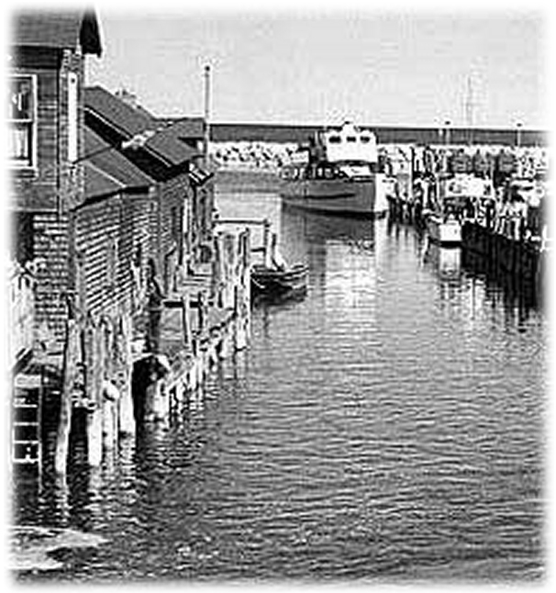
Island Excursion Attendees ~ Where to Go, Where to Park in Leland.
If you’re going to the island, you’ll find the Manitou Island Transit dock in Leland’s Fishtown ... at the end of River Street, Leland’s main downtown cross street. Things are often hectic on the dock just before sailing time, so unless you have things to unload, please proceed directly to the parking area ...
- Turn right (east) off Main St (M-22) onto River Street at “The Early Bird” restaurant.
- Turn right on Chandler Street
- Turn right at either East Boulevard Drive or Oak Street, at the “MIT Parking” sign
- Park anywhere on the open field in that area.
Parking is free for island excursion participants, by special arrangement with Manitou Island Transit. Show your membership card if asked. MIT provides transportation from the parking area to the dock. If the red MIT truck isn’t waiting for passengers it will soon return. If you have time, you may wish to walk the short distance to the dock. Simply return the way you came. But please note ...the boat leaves promptly at 10:00 AM!

