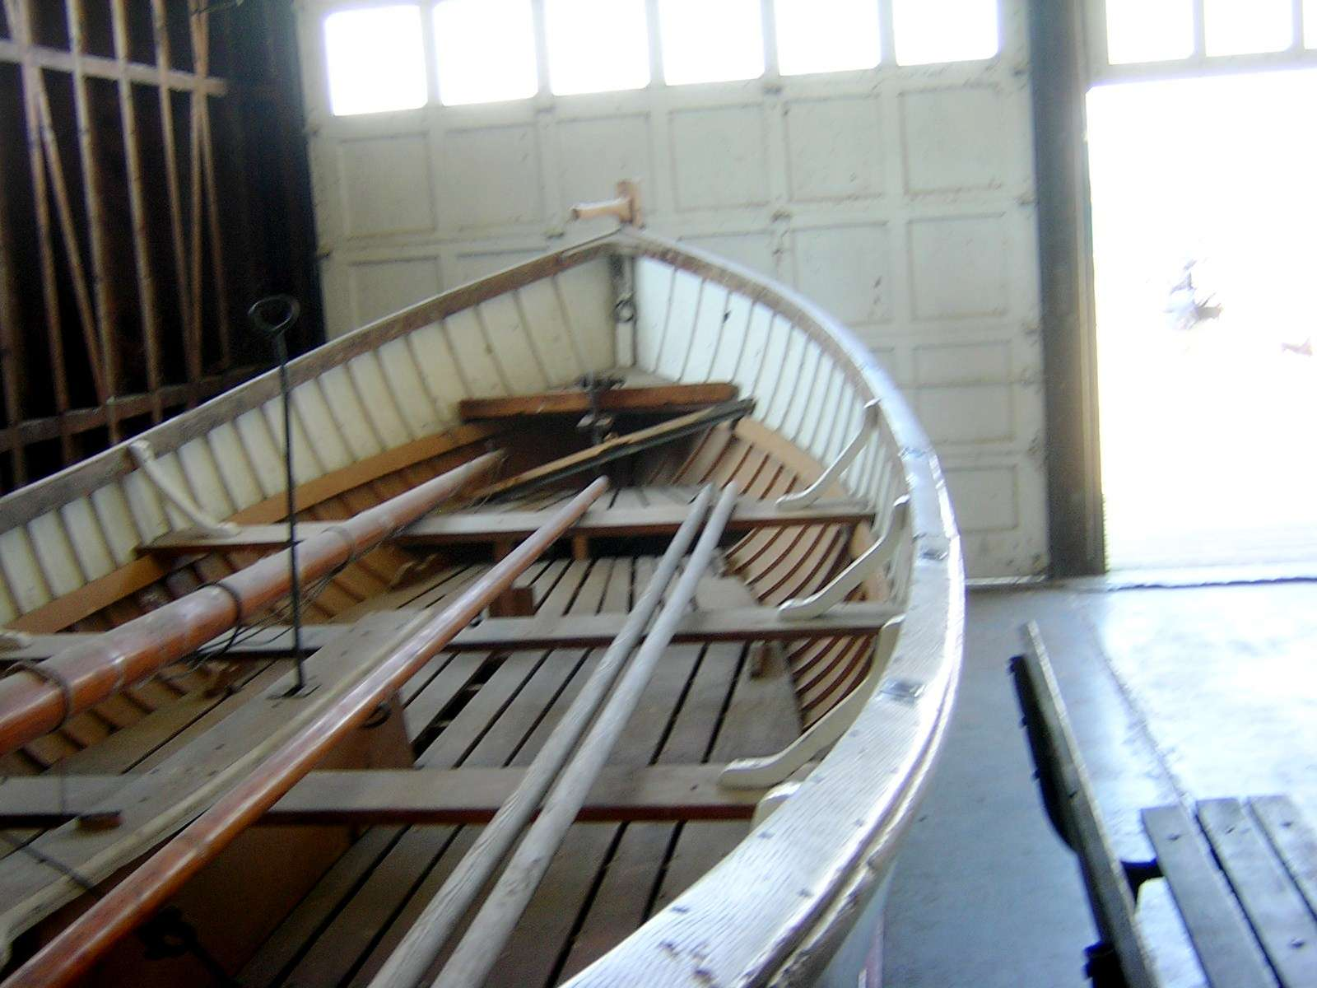
2006-2007
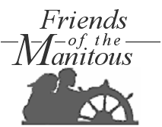
Annual Report

Board of Directors
President, John C McCann
Vice President, William Hatton
Secretary, Frances B. Oder
Treasurer, Shirley Peake
Hospitality Director, Mary W. Ward
Publicity Director, Linda D. Maddocks

Advisors
Youth Advisor, Michael Philbrick
Lakeshore Liaison, Patsy Carpenter
LHS Liaison, Joan D. Blackwell
Historical Advisor, Jessie Cunningham
Cultural Issues, H. Westcott Brown
Archivist, Thomas K Jones
Historic Architect, James G. Deepak
Legal Affiars, Elizabeth B. Diamonstein
MNA Liaison, Adarsh Davenport
Independent Sector, Beverly David

Annual Report

Mission Statement
The Friends of the Manitous helps preserve the history and cultural traditions of Michigan’s Manitou Islands. We assist in the collection and preservation of knowledge about the Islands, develop and distribute educational and interpretive materials and programs, promote the proper care and maintenance of historic and cultural assets, and serve as volunteers assisting the Sleeping Bear Dunes National Lakeshore in the delivery of rich visitor experiences.

Friends of the Manitous
PO Box 987
Empire, MI 49630-0987

Ph: 1-800-555-1212
Email: secretary@friendsofthemanitous.org
Internet: www.friendsofthemanitous.org

Friends of the Manitous is ..
a Michigan Nonprofit corporation (#987654)
a 501(c)2 exempt public charity
Approaching the Tipping Point
FROM THE PRESIDENT
A tipping point is neither a beginning nor an end. It’s the point at which competing paradigms suddenly shift. The old finally gives way to an irrevocable demise as the new experiences a final burst of energy, rising to eminence as the new order of things.
Friends of the Manitous began as an annual reunion of former islanders, and remained that for over twenty-five years. But the aging of our venerable charter membership has, over those years, reduced our ranks though attrition, and diminished our effectiveness. Over the past several years, boards have made well-intentioned efforts to reverse these trends, but they have been short-sighted, hastily conceived and inconsistent. Hence, the results have been disappointing.
In a more global perspective, it is also true that small charitable organizations, as a class, are enmeshed in a similar struggle for survival. This arises primarily from what has been referred to a our declining interest in social engagement. Some blame it on “X-Generation” attitudes which seem to be centered on self. Others point to government’s intrusions into realms that used to be left as the province of charitible organizations, such as churches, foundations and public charities. Yet, others point to the statistics showing that charitable giving and volunteerism is higher than it has ever been, but is distributed over an ever-growing number of nonprofit organizations. Whatever the case, it is clear that we must look well beyond our provincial interests and concerns, meeting people where they’re philosophically at with an agenda that is highly competitive.
The broad-based initiatives unveiled at last year’s annual meeting have begun to turn things around, as perhaps never before. They entail a depth and breadth of shared visions and a quest for excellence that is shifting the scales and providing momentum to the transformation of the Friends. I believe we are just now at the “tipping point” … having finally broken out of our self-limiting cognitions of the Friends as a close knit and rather exclusive “club”, now rushing towards a more open and inclusive society of people with more broadly based and ambitious personal agendas.
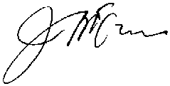
We are, of course, still a long way from achieving the outcomes we seek. Success will require more hard work and a redoubling of our commitment to service and collaboration in the spirit of the Lakeshore community’s values, and the values of our larger American community. But I heartily commend the staff and voluteers who have helped bring this year’s success, and humbly thank all the members, contributors, donors and patrons for their support in helping the Friends reach this “tipping point”.

Projects, Programs & Events
SOUTH MANITOU ISLAND SCHOOLHOUSE
"Historic and cultural points of interest on the islands truly enhance the richness of the visitor's experience. Achievements such as your restoration of this little schoolhouse will be valued by our guests for decades to come."

Ben White
SLBE Superintendent
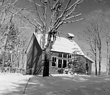
The schoolhouse on South Manitou, about 100-years old, was built to comply with compulsory education laws passed in the late nineteenth century. After fifty years of use, it stood abandoned until being acquired by the Lakeshore in the 1970’s. Its last use prior to that was for hay storage. Over the past thirty years, the Lakeshore has performed stabilization work as needed to save the structure, but has never had enough money available in the budget to permit its restoration.
Over the past two seasons, Friends crews have worked weekends under the direction of Project Coordinator Glenn Graats to restore the schoolhouse to the approximate condition in 1939, its last year of use as a classroom for island children. The work is nearly completed, and is well under-budget! $10,000 was originally allocated to this two-year project, and it appears that upon completion late next month, the cost will total only about $7,650. The restored schoolhouse will now be a regular stop on day-visitor tours, and will be opened by island interpreters for other visiting groups and special events.
ANNUAL ISLAND EXCURSION
The island ferry was sold out for the first time ever by our last excursion to South Manitou Island, and had to make a special trip to service campers returning to the mainland. The annual trip
has become increasingly popular. Events include a free catered picnic lunch, a memorial service at the island’s historic main cemetery with a special dedication by a contingent of Civil War soldiers, free motor tours of the island with visits to historic farmsteads, light station tours, and a time for socilaizing on the lawn of the old Coast Guard Station. The cruise between the mainland and the island can sometimes be an adventure in itself. Each year more activities and events are added, and the tour now attracts members of all ages. Youngest in the above group was 11-months; the eldest was 96-years old!
RECOVERING VERNACULAR AGRICULTURAL LANDSCAPES
"The attempt to derive meaning from landscapes possesses overwhelming virtue. It keeps us constantly alert to the world around us, demanding that we pay attention not just to some of the things around us but to all of them--the whole visible world in all of its rich, glorious, messy, confusing, ugly, and beautiful complexity."

Pierce F. Lewis
Association of American Geographers, Professor of Geography Emeritus at the Pennsylvania State University
The story of Rosen Rye is known to many. J. A. Rosen, a Russian student at Michigan Agricultural College in 1908, sent for the original seed to his father back in his home land. Working with this material, Frank A. Spragg, plant breeder at Michigan State College, developed a highly hardy and productive strain of rye.
The most famous of Rosen rye growers were George and Louis Hutzler of South Manitou Island. Here, in perfectly isolated island fields, these growers produced Rosen rye of the finest, purest stock, keeping up a fountain head of pure seed that other rye growers used to renew their suppiles when cross pollination contaminated seed crops.
Rosen rye is still grown world-wide today. J.A. Rosen, the student who remembered his father's good rye and introduced it in America 100 years ago, returned to Russia to become a high official in Soviet agriculture.
The Friends are now engaged in the recovery and permanent maintenance of the historic Hutzler rye fields.
PORT ONEIDA FAIR
"The long, heroic era of the lighthouse keeper has come to an end. Without caretakers, the lights, keepers' houses and other buildings have become easy targets for vandalism and damage caused by storms. In just a few years these historic structures deteriorate beyond repair. Lost with them is the treasured maritime history of our country, the witness of countless lives saved, and the beauty of their architecture."

James Highland
Executive Director
The Lighthouse Preservation Society
Port Oneida was one of the earliest mainland settlements in the Leelanau County area, named after the S.S. Oneida, the first steamboat to tie up at the dock newly constructed by wood merchant Thomas Kelderhouse. The settlement had close commercial, vocational and ancestral ties with the islands, especially South Manitou, which was the main center of commerce at the time. After the timber was depleated, its families turned to farming, which provided their livlihood for more than 100 years. It’s 3000 acrea now comprise the Port Oneida Rural Historic District.
The annual Port Oneida Fair is hosted by the Lakeshore, co-sponsored by the Friends, with grant funding from the National Endowment for the Arts and the Michigan Humanities Council. It provides interesting and educational entertainment for over 10,000 park visitors the first weekend in August. The Fair provides us with a unique venue for sharing stories and information about the Manitou Islands with visitors of all ages. Our old time toys and games exhibit provides kids (of all ages) and opportunity to experience “fun” in the same ways as the kids who grew up on Port Oneida and Island farms during the area’s heydays.
NORTH MANITOU SHOAL LIGHTSTATION
The Friends have completed negociations with the U.S Coast Guard and General Services Administration for a historic preservation lease of the offshore light known locally as “the Crib”. The termless lease will be formally signed in Cleveland next month. Restoration work will begin with a formal “summary of existing condition”, after which bids will be sought from professional contractors. Offshore lights are so difficult and expensive to work with, that few preservationists are eager to undertake such projects. The estimated cost of our project is $2.1-million, most of which will be raised as grants from grovernment and nonprofit foundations involved in maritime preservation activities.
Challenges for 2007 and Beyond
PARTNERING PROVIDES OPPORTUNITIES
" The administrative history of Sleeping Bear Dunes National Lakeshore is the story of one park unit's attempt to meet its congressional mandate in an era of expanding responsibilities and often uncertain financial means, in a beautiful but often hostile place."

Theodore J. Karamanski
"A Nationalized Lakeshore"
The Sleeping Bear Dunes National Lakeshore finally became a reality in the early 1970’s, after several years of rankling debates and lawsuits. During those negotiations, the word “wilderness” found it way into the enabling legislation. At the time, only the proponents of wilderness knew what that word meant in the legislation’s vernacular.
To their dismay, local people who had supported the national park initiative soon found out. The National Park Service’s original mandate, as they understood it, was to return the area to its original pristine condition, with no visible evidence of man’s ever having been there. As historic and cultural assets moldered and crumbled, the area began to loose much of the charm that prompted the national park initiative in the first place. By the time that thinking changed, much had already been lost.
Nevertheless, much still remains … much more, in fact, than the park service is capable of caring for, given the budget constraints of the past twenty years. The National Park Service is therefore embracing “partnerships” with nonprofit organizations … NPO’s that can legally solicit funds for much-needed maintenance projects, and who can recruit and train seasonal volunteer helpers for the parks.
In addition to providing for visitor services, the Lakeshore’s inventory of historic and cultural assets numbers hundreds of units, most of which need stabilization and restoration work, and all of which require perpetual maintenance care. Many of these are located on the islands. Herein, then, lies a purpose for our organization, a purpose that will continue indefinitely.
Our role as a partner to the Lakeshore has thus far involved providing money and volunteer support as various needs which were within our capabilities presented themselves. Our zeal to participate also varied from one board to the next.
Taking the long view, it is clear that the future of the Friends depends upon changing our approach from fitting needs to capabilities, to adjusting capabilities to needs. This will involve a formal commitment to “partnership”, creating a system for taking inventory of all unfunded and underfunded restoration, maintenance and interpretive needs on the islands, then building the financial and human resources within our organization as needed to meet these needs indefinitely.
Roll of Contributors
2006/2007 – ALL GIFTS ARE EQUALLY VALUED
Ms. Joan D. Aaron CPA
Dr. & Mrs. James F. Allen
Dr. & Mrs. William M. Bangel
Mr. & Mrs. James G. Batterson
Ms. Deloris Becker
Mrs. Patsy Blackwell
Dr. Jacqueline Bontemps
Mrs. Douglas C. Broad
Mr. & Mrs. Randolph P. Bryant
Dr. & Mrs. Ernest P. Buxton III
Ms. Donna W. Chisman
Mr. & Mrs. Thomas L. Coile
Mrs. Mary G. Cousins
Mr. & Mrs. John E. Decher III
Dr. & Mrs. Adarsh Deepak
Katie & Jeff Ellington
Mrs. Christine P. Ferguson
Dr. & Mrs. Allen Findley
Mr. & Mrs. Arthur Fleming
Mr. Chip Goldstein
Mr. & Mrs. Baron J. Gordon
Maj. Gen. (Ret.) &
Mrs. John R. Greenway
Mrs. George S. Grier III
Mr. & Mrs. Terry E. Hall
Mr. & Mrs. George A. Hamilton
Dr. & Mrs. William O. Harris III
Ms. Helen C. Hill
Dr. Rita C. Hubbard
Mr. & Mrs. Richard W. Hudgins
Mr. & Mrs. Thomas N. Hunnicutt
Mr. & Mrs. Brian P. Hutchens
Mrs. Charles K. Hutchens III
Mr. & Mrs. Joseph F. Hutchko Jr.
Ms. Jonzennie M. Jones
Drs. Michael & Linda Kelley
Ms. Linda S. Kenwood
Mr. James R. Knight & Ms. Mary Gibson
Ms. Anna L. Liverman
Dr. & Mrs. John L. Lockhart
Dr. & Mrs. Thomas A. Mackenzie
Mr. & Mrs. Michael Maddocks
Dr. & Mrs. Lambert P. McLaurin
Mrs. Tina D. McManus
Mr. & Mrs. Thomas W. Meehan
Mr. & Mrs. C. William Moore
Mr. & Mrs. Paul Moses
Mr. & Mrs. James E. Neff
Dr. Douglas L. Nelson &
Dr. Susan E. Mackel
Mr. & Mrs. Edwin C. Oyer
Mrs. Catherine A. Parcells
Dr. & Mrs. William F. Peach Jr.
Dr. Roger Perry
Dorothy McM. Phillips
Mrs. Henry S. Read
Ms. Holly Rice & Mr. Vince Gilligan
Mrs. Margery D. Rucker
Dr. Lisa Marie Samaha &
Christopher Scott
Dr. Glenn H. Shepard
Mr. Manfred Freeman
Mr. Carlton S. Abbott
Ms. T. Addison
Mr. & Mrs. Juerg Aeschbach
Lt. Col. & Mrs. Leroy Allen
Mr. & Mrs. Joseph D. Amott
Mrs. Betty L. Anglin
Ms. Jean Atkinson
Mr. Jacob Baer
Dr. & Mrs. R. Rives Bailey
Mr. & Mrs. George Bains Jr.
Mr. & Mrs. Jim Bales
Mrs. Alice C. Barrs
Mrs. Laura Bateman
Mr. & Mrs. Hank Beckstoffer
Mr. & Mrs. Fred L. Beissner Jr.
Ms. Betty M. Blanchard
Ms. Kathleen Bowman
Mr. Robert Braig
Mr. & Mrs. Thomas R. Brooks
Mr. & Mrs. Joseph J. Bryant Jr.
Mr. & Mrs. Joseph C. Buckman
Mr. & Mrs. William R. Burnette
Mr. & Mrs. Lonnie A. Byrd
Ms. Marguerite Peterson Cabaniss
Mr. & Mrs. Ran Cabell
Dr. & Mrs. Thomas P. Caine Jr.
Dr. Thomas W. Caldroney
Mr. Robert Camposano
Ms. Phyllis M. Caro
Mr. & Mrs. William R. Carpenter III
Mr. Darryl O. Case
Dr. & Mrs. Douglas H. Chessen
Mr. Charles R. Cochran
Ms. Shari E. Cohen
Mr. & Mrs. Mark W. Cole Jr.
Hon. & Mrs. H. Vincent Conway Jr.
Mrs. Trilby Cooney
Mr. & Mrs. C. Marcus Cooper Jr.
Ms. Carolyn S. Corazzi
Ms. Charlotte H. Cornell
Mr. & Mrs. Gary D. Curbow
Mr. Dan Curran
Mrs. Douglas C. Curtis
Mrs. Kathryn Cutler
Mrs. Loretta Dahnke
Dr. & Mrs. John C. Daimler
Dr. & Mrs. James K. Davis
Ms. Wendy C. Drucker &
Mr. Michael R. Piercy
Mrs. Andrew W. Duncan
Mr. & Mrs. James Dunn
Ms. Mary Elizabeth Dupree &
Mr. Steven Meyer
Ms. Barbara W. Ellerbee
Mr. & Mrs. Thomas E. Fass
Mr. Jim Feltman
Carol & Carter Ficklen
Mr. & Mrs. Vance B. Field
Mr. & Mrs. A. J. Firestone
Mr. & Mrs. Don Fitch
Mrs. Joan Rushin Folsom
Mr. & Mrs. William. H. Forrest Jr.
Mr. & Mrs. Bruce Fowler
Mr. Charles H. Fox Jr.
Hon. & Mrs. Joe S. Frank
Ms. Diana D. Freeman
Ms. Tina W. Frye
Dr. & Mrs. Wallace K. Garner
Mr. & Mrs. George K. Garrison
Col. & Mrs. Jack Gaustad
Mr. & Mrs. Gordon L. Gentry Jr.
Mr. & Mrs. Ralph M. Goldstein
Mr. & Mrs. Clifford Goodnight
Mr. & Mrs. Pax A. Goodson
Mr. Jerome Gordon
Ms. Diana Blanchard Gross
Mr. J. Emmett Gwaltney
Mr. & Mrs. Jerry Hagelberger
Ms. Iris Hill Hancock
Mrs. George S. Hankins
Janet & Steven Harris
Mrs. John P. Harrison Jr.
Ms. Nancy Lenz Harvey
Mr. & Mrs. W. Scott Havens
Mr. & Mrs. V. Ansell Hawkins
Mrs. Anne B. Hazen
Mr. & Mrs. Arthur Henderson Jr.
Mr. David Henley
Mr. & Mrs. Thomas P. Herbert
Mr. David R. Herring
Mr. Michael Hicks &
Ms. Nadine Thompson
Mrs. Doris Atkinson Hill
Capt. & Mrs. John W. Hilt
Mr. & Mrs. Edward. L. Hoffman
Mrs. Maurice Hoffman
Mr. & Mrs. Wayne C. Hogge
Mr. & Mrs. James B. Hollingsworth
Mr. & Mrs. John H. Holt
Mr. & Mrs. M. Quincy Holt
Mr. & Mrs. C. A. Swanson Hornsby Jr.
Mr. & Mrs. James M. Horton
Dr. Sharon Lee Hostler
Mrs. Valeria T. Hundley
Mr. & Mrs. Brian P. Hutchens
Mr. Daniel Jobson
Mr. & Mrs. David R. Johnson
Mr. and Mrs. Fount Johnston
Mr. & Mrs. Kendall C. Jones
Dr. & Mrs. Vincent Joseph
Ms. Gaylene Kanoyton
Ms. Nancy Kearney
Mr. Paul Kennedy

Financial Reports
STATEMENT of ACTIVITIES
2006-2007 2005-2006
Revenues
Grants, Gifts & Contributions $ 52,583 $ 57,671
Membership Dues 15,282 14,951
Income from Investments 1,646 1,654
Miscellaneous Income 264 421
Total Revenues 69,775 74,697

Expenses
Programs
Restoration Projects 24,274 18,365
Maintenance Activities 18,758 22,425
Interpretation 8,542 7,501
Fundraising Expense
Newsletters 2,900 3,226
Island Excursion 3,200 3,500
Port Oneida Fair 5,000 5,000
Administrative Expense
General Office Expense 2,925 2,876
Telecommunications 708 659
Printing and Postage 276 392
Meetings
Board Meetings 1,659 1,587
Annual Meeting 2,652 1,836 Miscellaneous Administrative Expense 186 205
Total Expenses 71,800 67,572
======= =======

Change in Net Assets $ (2,025) $ 7,125

STATEMENT of FINANCIAL CONDITION
Assets
Cash $ 3,729 $ 10,327
Inventory
Promotional Items 2,900 3,226
Materials and Supplies for Projects 10,297 5,452
Office Supplies 129 243
Property and Equipment
Boats and Vehicles 37,500 39,200
Total Assets 54,555 58,448

Liabilities
Liabilities
Accounts Payable $ 3,729 $ 10,327
Contributions, Gifts & Grant Payable 0 0
Other Liabilities 0 0
Total Liabilities 3,729 10,327
Net Assets
Net Assets 50,826 48,121
======= =======
Total Liabilities and Net Assets $ 54,555 $ 58,448

Statistics

Membership
June 30, 2007 – 654
June 30, 2006 – 539

Contributors
FY06/07 – 325
Individuals: $31,525
Corporate: 19,500
Other: 1,558
FY05/06 – 368
Individuals: $42,136
Corporate: 10,000
Other: 5,535

Attendance
06 Annual Meeting – 321
06 Island Excursion – 227
06/07 Board Meetings – 8*
(*) average

Volunteers
Island Workshops – 97
Island Interpreters – 12
Adopt-A-Trail – 27
Administrative – 6

Literature Distribution
Brochures – 654
Visitor Guides
North Manitou – 1,262
South Manitou – 4.256
Newsletters – 842*
(*) for promotional purposes

Volunteers

Island Workshops
Warren Stephens Leroy E Stiff
Harriet N Storm Robert Strasser
Lewis Strickland Lucile & Jane Sutterer
Raymond Suttle Jr. Lise Swensson
Allen C Tanner Jr. Ken Taylor
Kensett Teller Charlie C Thesz
Eugene Temple Jr.
Michael Tiller Island Interpreters
Edward Tilles Jacqueline Tobin
Barbara A Todd Jesse Todd Jr.
Robert Tolley Larry M. Topping
Robert Trujillo Robert Turbyfill
Rebecca Clough Elwin Upton
Renate Kasch Charles Vaughan
Douglas S Wade Julia Wainwright
Michael Carter William E Wallace
Karen Ward Charles Wentworth II
Thomas Wessells Jr. Steve & Mary Wetmore
Al White McKim Williams
Genevieve Wilson
Dave & Molly Winker Adopt-a-Trail
Alan Witt Nancy Camden
Shar Wolff John & Jamie Wood
Charlie & Charlene Wornom Paul H Wornom
Lynda Wright John & Jimmy Mahoney
Dan Malone Steven & Jane Marks
Jeff Martinovich Joseph Mastaler
Travers O Mayhew Bernhard & Mary Mecking
Ken & Marilyn Meek Braden Miller & Sue Votz
Joyce A Miller Paul F Miller
Vic Miller Ronald Minetree
John E Mitchell John B Morgan II
Harrell & Mildred Morris Henry Mullins IV
James M. Mullins III Kevin Murphy
Amy Myers Mary C Neale
Molly & Vernon Netto
John E Sim Administrative Help
L Wallace Sink Conway W. Smith
Bernard Smith Jr. Leon K Smith
Robert Carrol Smith Robert Smola
Gilbert J Snyders Dorothy Sparrow
James W Speegle John Stegeman
G. Bernard Smith Jr. Leon K Smith
Robert Carrol Smith Robert Smola
Gilbert J Snyders Dorothy Sparrow
James W Speegle John Stegeman
“Never doubt that a small group of thoughtful, committed citizens can change the world; indeed, it's the only thing that ever has.”

Margaret Mead
American Anthropologist
1901 – 1978

Postscript

By reading through the annual report, we hope you have reached the conclusion that by working together with a durable strategic plan, we can become wholly effectual in preserving and interpreting the historic and cultural assets of North and South Manitou Islands, thereby guaranteeing rich visitor experiences, while also assuring the perpetual effectiveness and viability of our organization.
Friends of the Manitous has brought focus and a platform to leverage resources in order to strengthen the Lakeshore's Islands Unit. Our history has taught us the futility of provinciality, and the power of collaboration and stewardship.
While our mission might seem small and highly localized, what we do serves the thousands who visit the islands each summer, a number that includes fellow Americans and people from all over the world. In order for America to function as a healthy democracy, every sector must continue to strive for excellence and work with others to serve the community. In the end, it is about individuals one by one stepping up to make a contribution.
Thanks to all those who have gotten the Friends this far, and to those who will join us in our future endeavors.

