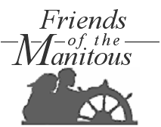

Policy
on
Intellectual Property Rights
Should work that a volunteer performs for Friends of the Manitous result in the creation of intellectual property rights, the volunteer agrees, as a condition of volunteer employment, that:
- such intellectual property shall be deemed a work made for hire owned by Friends of the Manitous Inc., and
- to the extent it does not qualify as a work made for hire for any reason, the volunteer irrevocably and unconditionally assigns to by Friends of the Manitous Inc. all rights, title, and interest in and to any such intellectual property rights, and
- this is true even if the material developed by the volunteer is published under his/her name by Friends of the Manitous or some other entity.
The volunteer further agrees that s/he will not make commercial use of the information or material developed while volunteering at Friends of the Manitous, either while volunteering for or after leaving Friends of the Manitous, without the express written approval of Friends of the Manitous.
________

CERTIFICATION

I, William R Strating, Secretary of the Friends of the Manitous, Inc., a Michigan nonprofit corporation, hereby certify that the attached Policy on Intellectual Property Rights was adopted by the Board of Directors of the Friends of the Manitous in a legally called meeting held on September 1, 2006, and further certify that after being put to vote, the number of votes cast for the Policy was sufficient for its approval.

IN WITNESS WHEREOF, I have hereunto set my hand this 1st day of September, 2006.

FRIENDS OF THE MANITOUS, INC.,
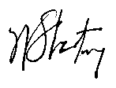
A Michigan nonprofit corporation

By: _____________________________
William R Strating, Secretary

